Advanced Engineering Mathematics, by Erwin Kreyszig 10th. Ed.

**Problem Set 1.2**

No. 1~8

CAS繪圖

No. 9



No.10

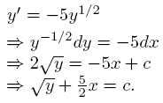

No.11



No.12

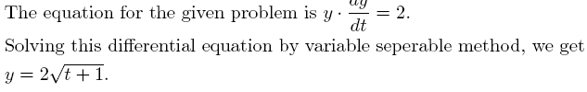

No.13

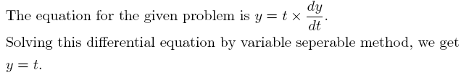

No.14

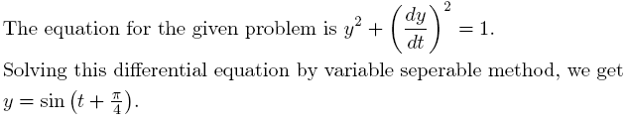

No.15



No.16



No.17

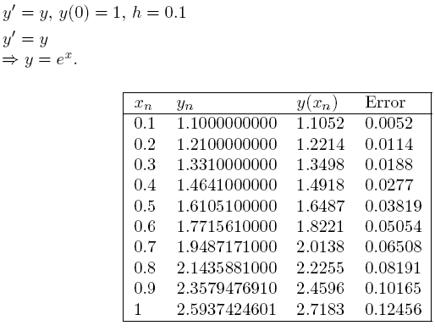

No.18

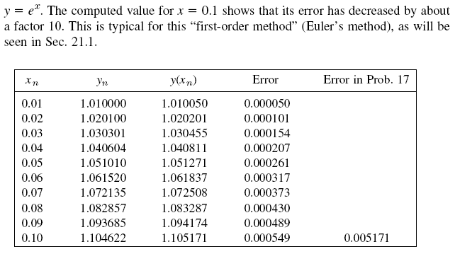

No.19

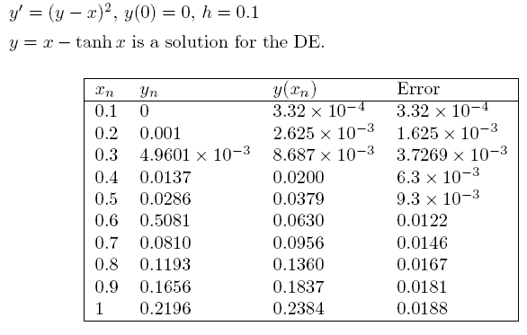

No.20

